Doug Strouth

CIS228

Chapter 5 City Jail exercise

Part 1  
INSERT INTO Criminals (Criminal_ID, Last, First, Street, City, State, Zip, Phone, V_Status, P_status)

VALUES (:Criminal_ID, :Last, :First, :Street, :City, :State, :Zip, :Phone, :V_Status,:P_status);

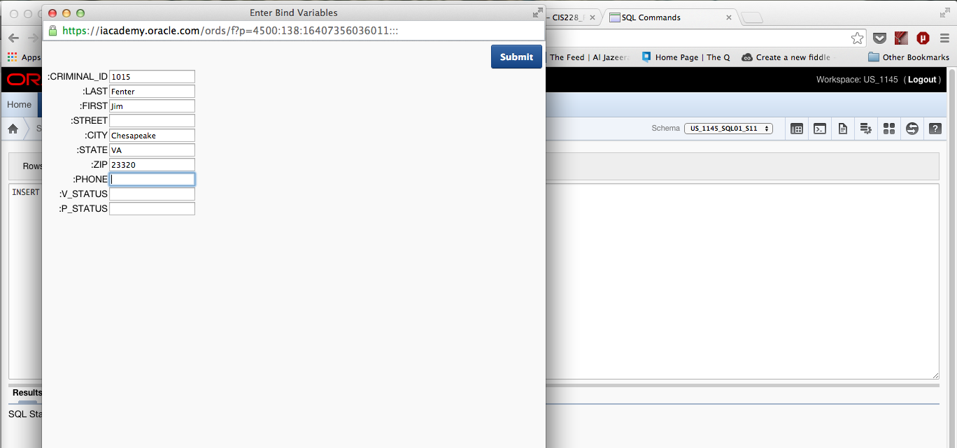

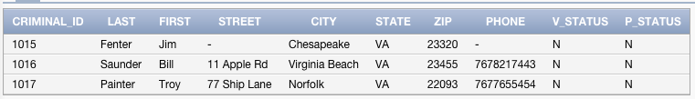

ALTER TABLE Criminals

ADD (Mail_flag CHAR(1));

UPDATE Criminals

SET Mail_flag='Y';

UPDATE Criminals

SET Mail_flag='N'

WHERE Street IS NULL;

UPDATE Criminals

SET Phone='7225659032'

WHERE Criminal_ID=1016;

DELETE FROM Criminals

WHERE Criminal_ID=1017;

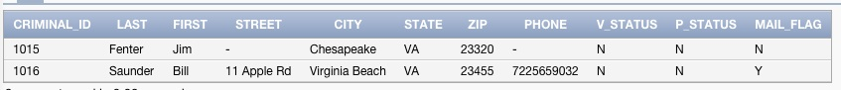

Part 2  
INSERT INTO Crimes (Crime_ID, Criminal_ID, Classification, Date_charged, Status)

VALUES(100,1010,'M',15-JUL-09, 'PD');

This statement returns error “ORA-02290: check constraint (US_1145_SQL01_S11.CRIMES_STATUS_CK) violated” because the value for Status must be either CL, CA, or IA and we have entered PD. Also, this statement is referencing a foreign key that does not exist. If I remove the status value and run the command again I get “ORA-02291: integrity constraint (US_1145_SQL01_S11.CRIMES_CRIMINALID_FK) violated - parent key not found”

INSERT INTO Crimes (Crime_ID, Criminal_ID, Classification, Date_charged, Status)

VALUES(130,1016,'M', ‘15-JUL-09’,'PD');

**“**ORA-02290: check constraint (US_1145_SQL01_S11.CRIMES_STATUS_CK) violated”

This statement still violates the check constraint on status, but no longer references a foreign key that does not exist so ORA-02291 is no longer a problem

INSERT INTO Crimes (Crime_ID, Criminal_ID, Classification, Date_charged, Status)

VALUES(130,1016,'P', ‘15-JUL-09’,'CL');

The error for this statement is “ORA-02290: check constraint (US_1145_SQL01_S11.CRIMES_CLASS_CK) violated” This statement violates the check constraint on the Classification column because it can only be F,M, O, or U, not P as entered above.